

**Qualcomm Car-to-Cloud Platform**

**Route Config Api Swagger Usage Document**

|  |  |  |  |
| --- | --- | --- | --- |
|  | **Prepared By / Last Updated By** | **Reviewed By** | **Approved By** |
| **Name** | Annet Jolly |  |  |
| **Role** | Developer |  |  |
| **Signature** |  |  |  |
| **Date** | May 20, 2021 |  |  |

Table of Contents

1. Swagger UI 1

1.1 Application-Controller 2

1.2 Message-Controller 3

1.3 Post data using swagger UI 4

2.1 Http Status Codes-............................................................................................................................5



This document specifies the stepwise details on how to use the Swagger

### **Swagger UI**

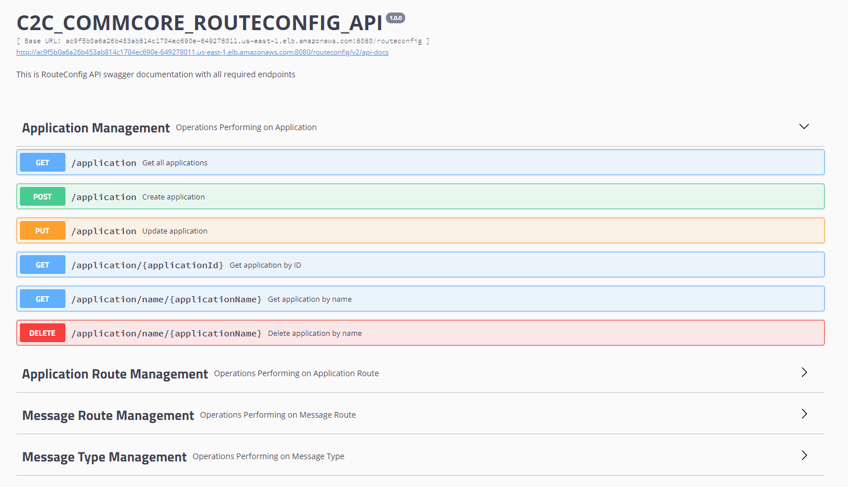

The picture above shows the Swagger UI for Route Config API. The API designed to perform basic crud operation and it is used by Dispatcher for routing. In this api an application and message type are created and use to create application route and message route. Here the Swagger UI helps to post the message request to the API and gets the response.

## **Application-Controller**

We have a table called application which has a foreign key relationship with application-route based on the field application_id. Both application-controller and application-route-controller are doing all the required crud operations.

Create an application using post mapping in application controller and generate application_id and use that application_id to create application-routes so that a single application_id will have multiple routes.

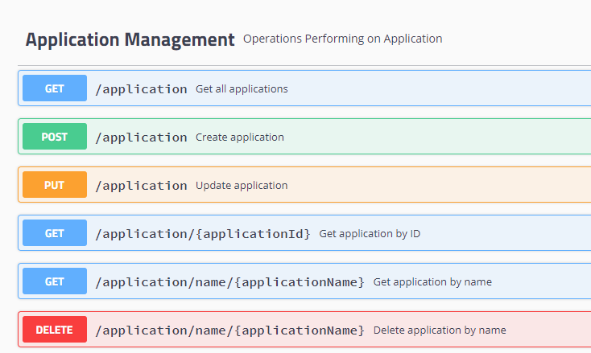

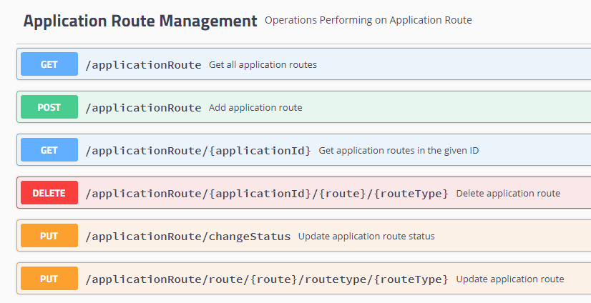

## **Message-type-Controller**

We have a table called message_type which has a foreign key relationship with message-route based on the field msg_type_id. Both message-type-controller and application-route-controller are doing all the required crud operations.

Create a message_type and generate msg_type_id and use that msg_type_id to create message-routes so that a single msg_type_id will have multiple routes.

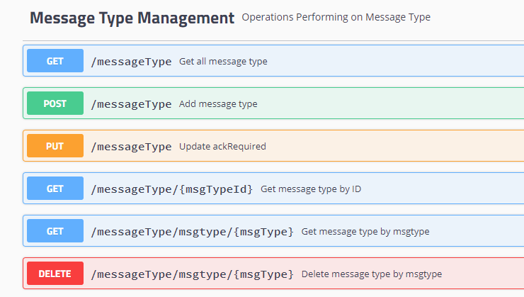

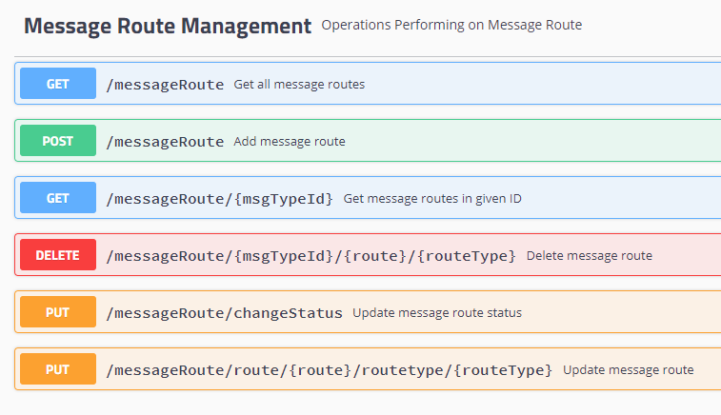

## **1.3** Sample Request and Response

1. Post data using Swagger

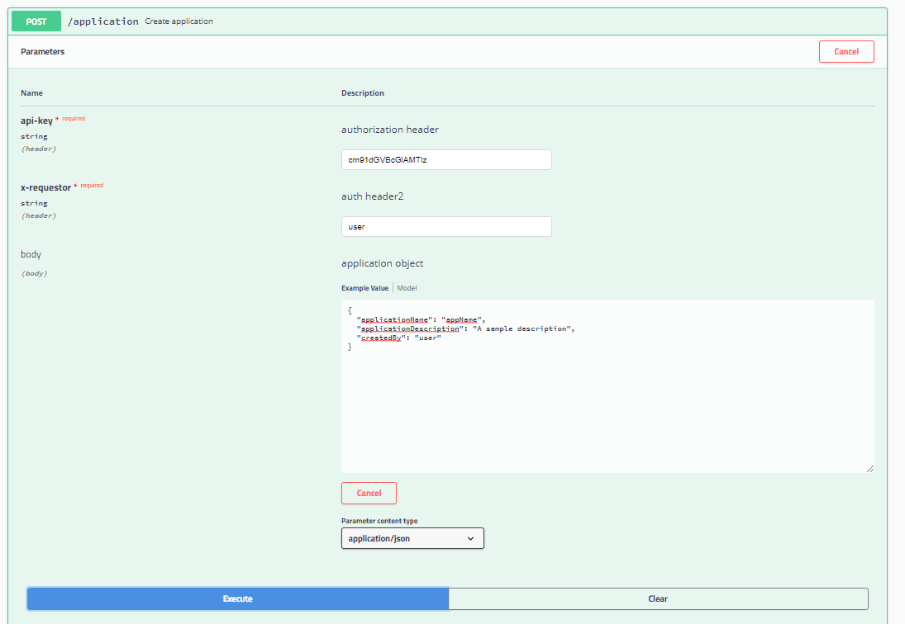

Steps Followed To post data:

1. Click on the Arrow that is adjacent to create Application.
2. Click on the POST option
3. Select the Try it out Button on the right



1. Add the Message
2. Click on Execute
3. Check the Response

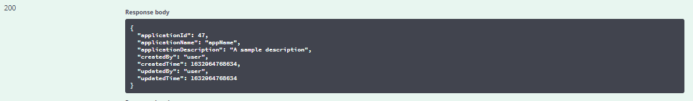

1. **Get Application by Id**

Sample Request

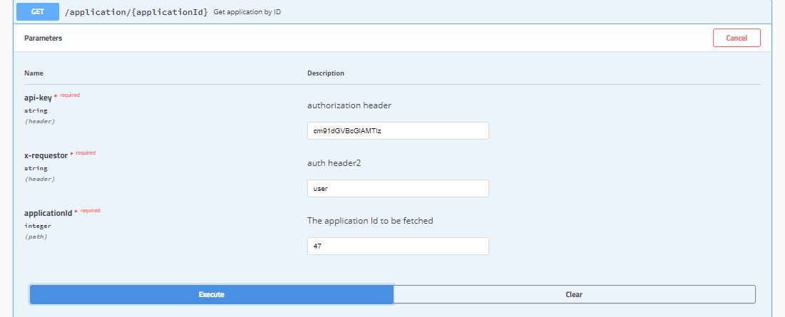

Sample Response

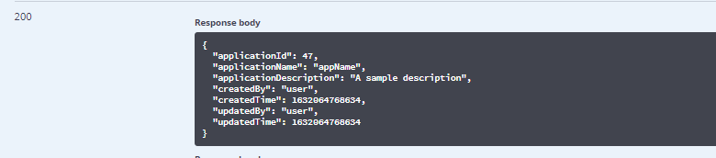

1. Get Application by Name

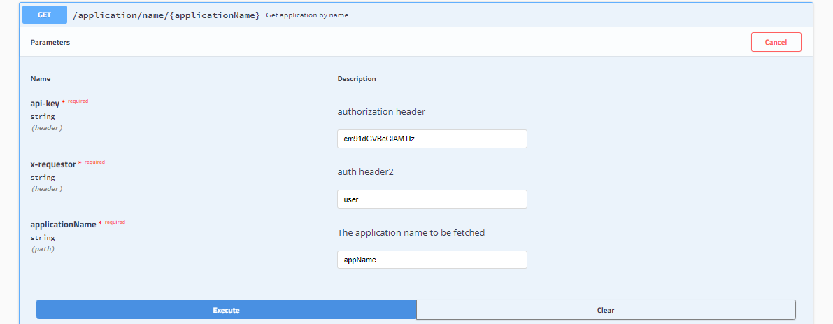

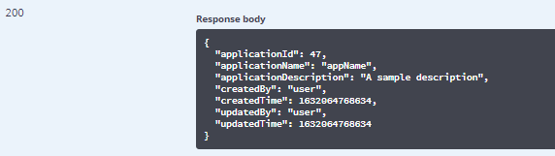

1. Update Application –To update Application description

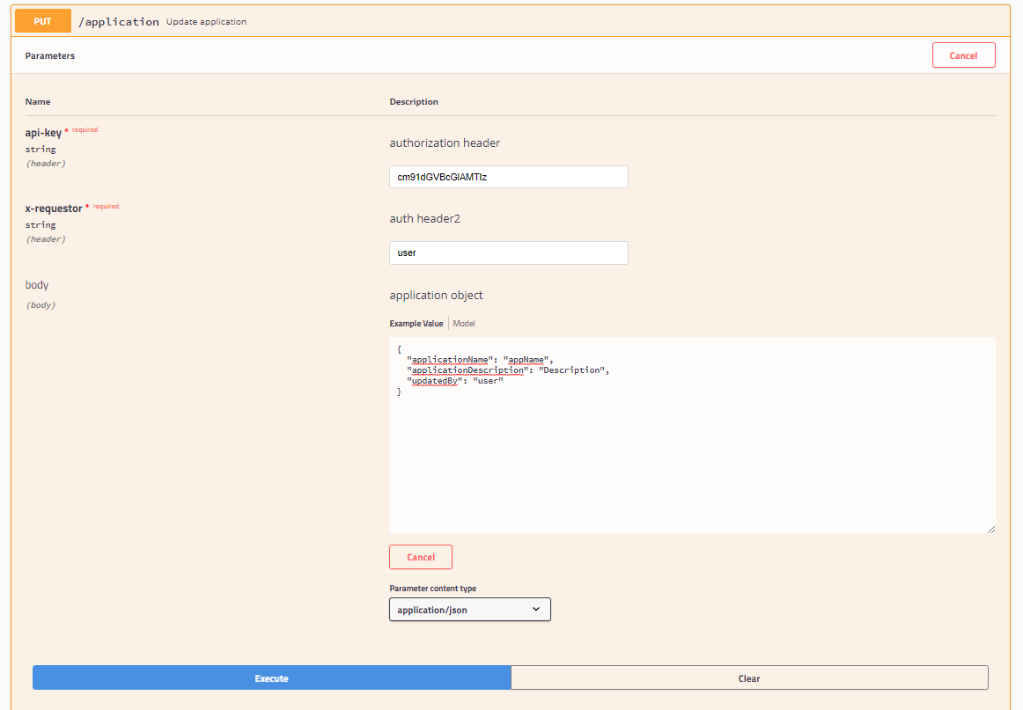



1. Get All Application

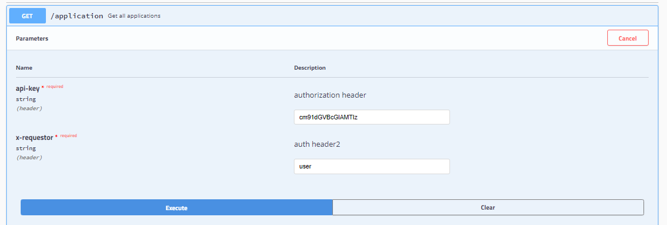

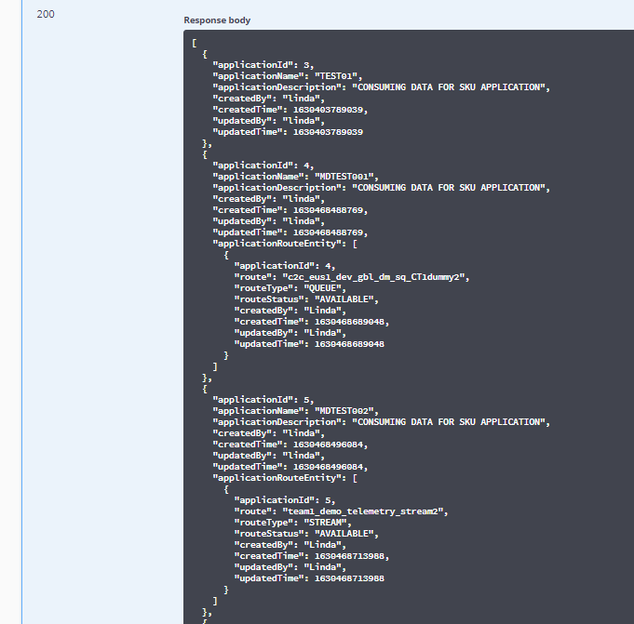

1. Get All Application Routes

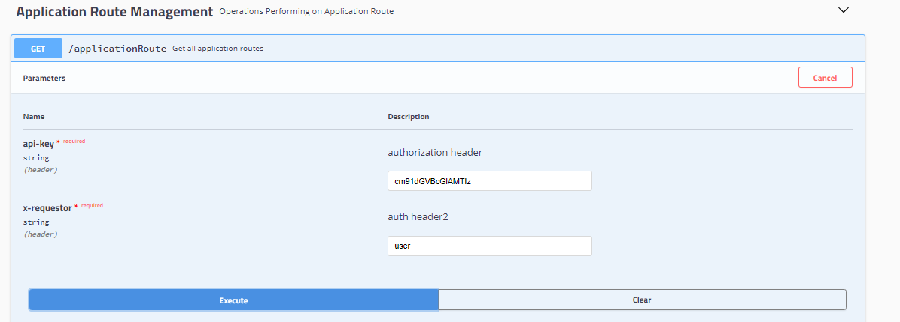

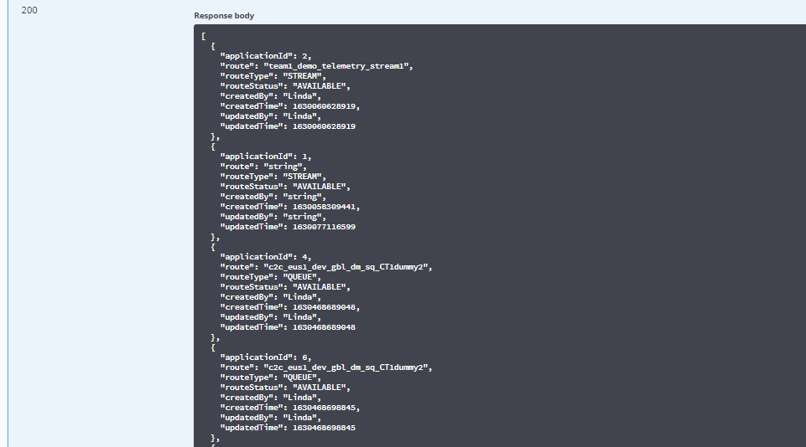

1. Post Application Route

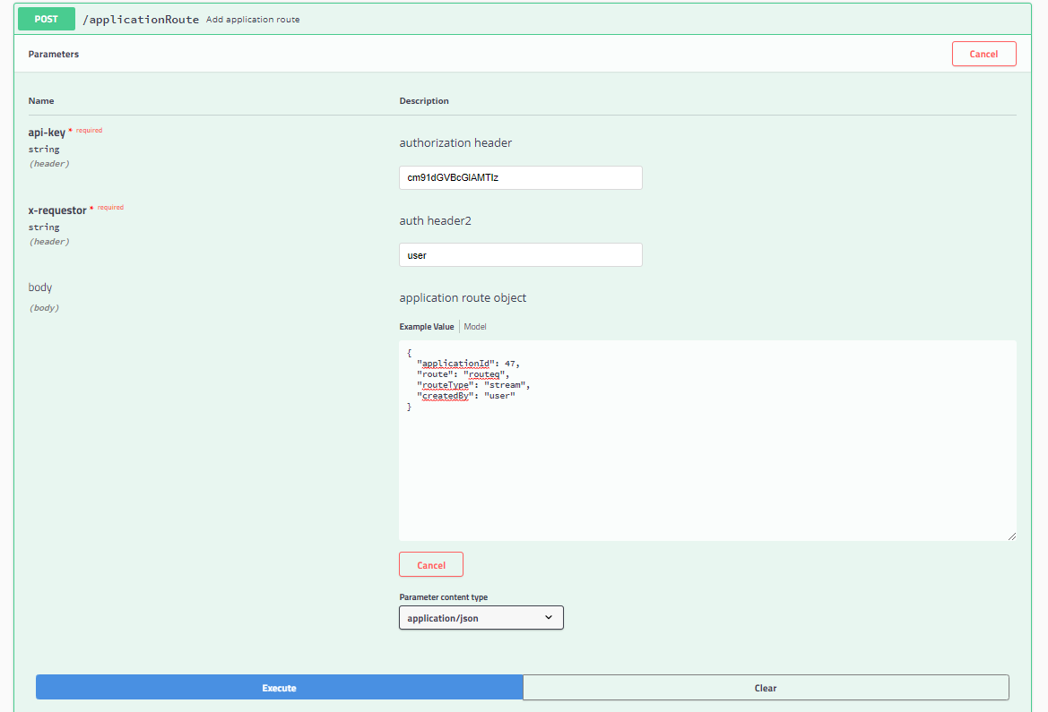

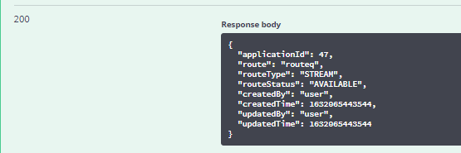

1. Update Application Route status – to available or not available

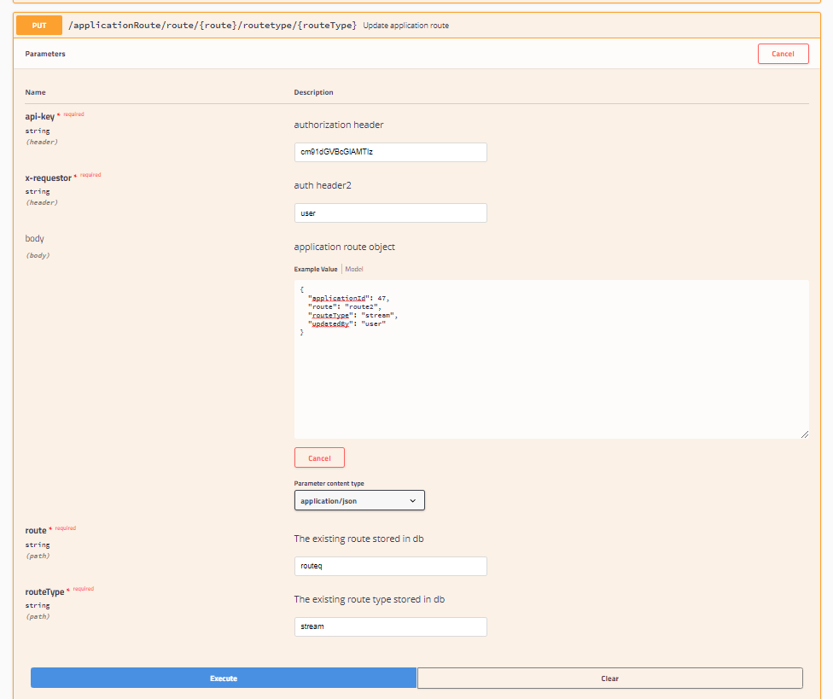



1. Get Application Route by Id

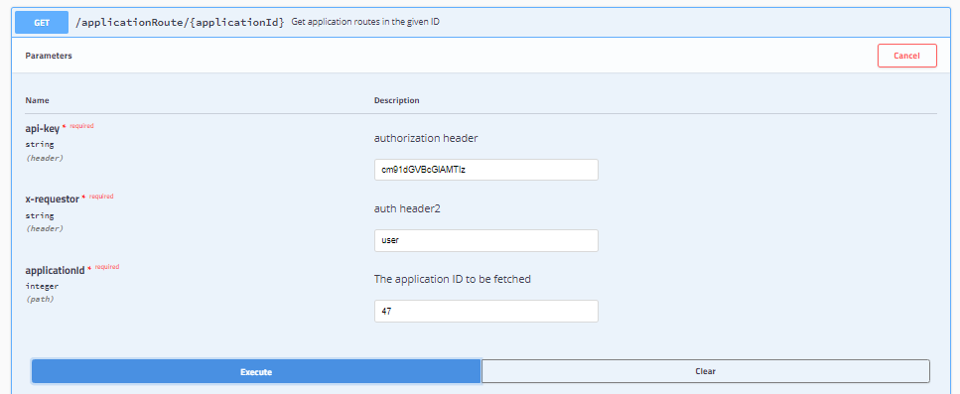

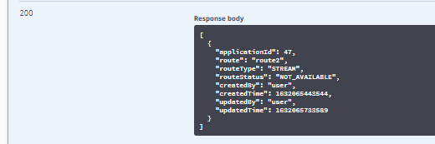

1. Delete Application Route

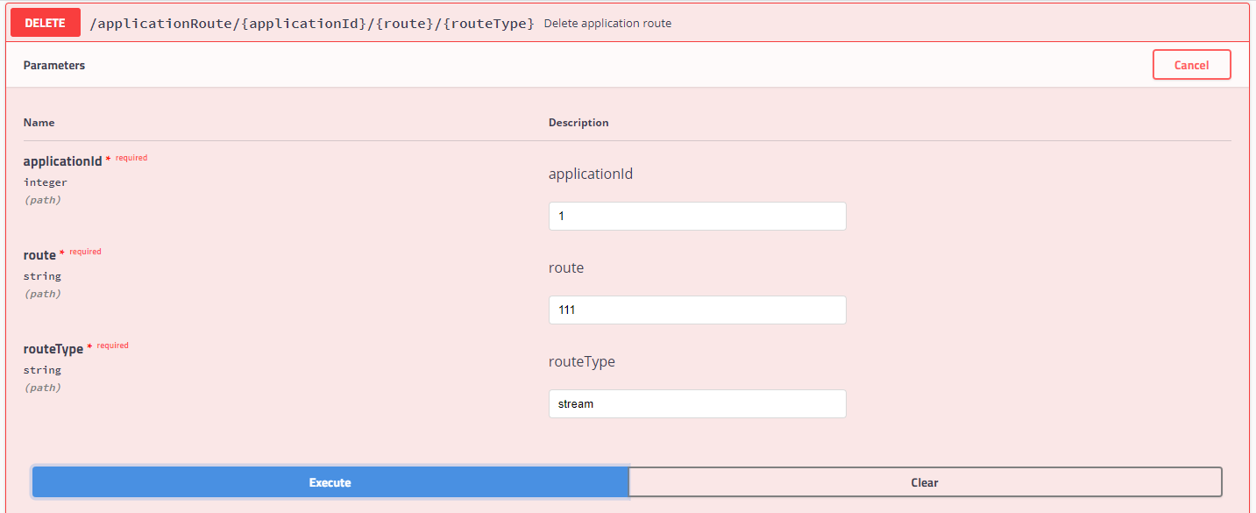

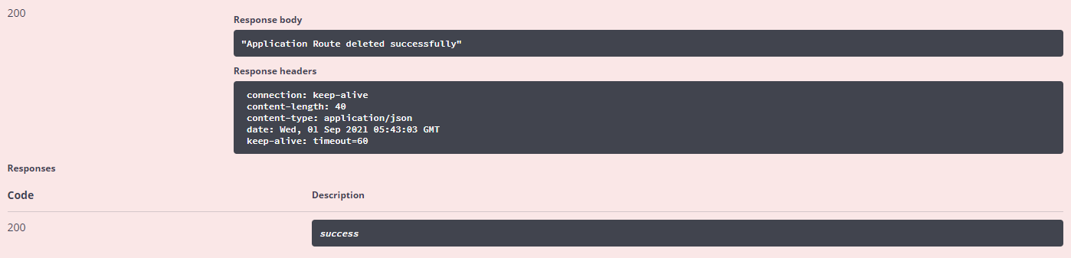

1. Delete Application

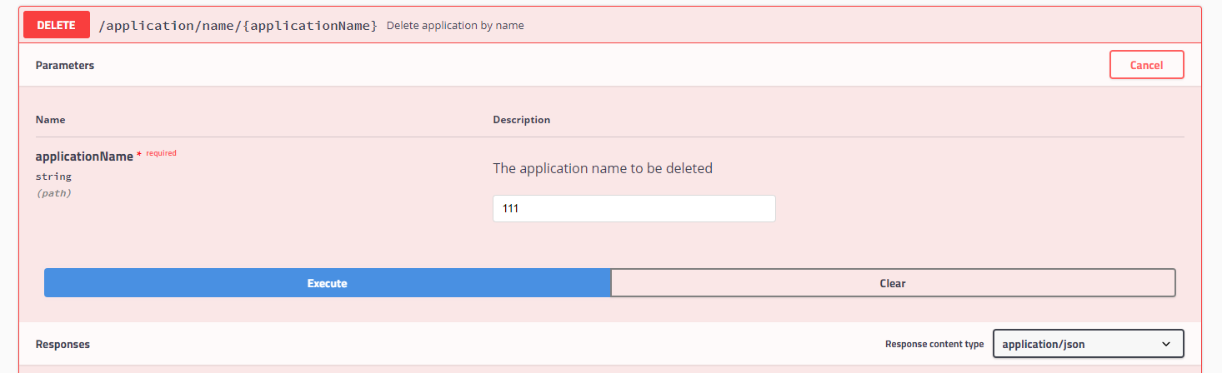

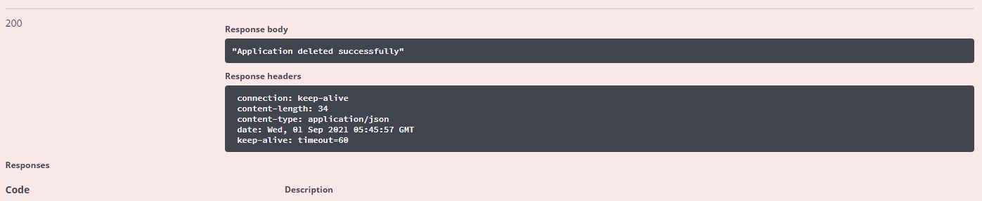

1. Update Application Route

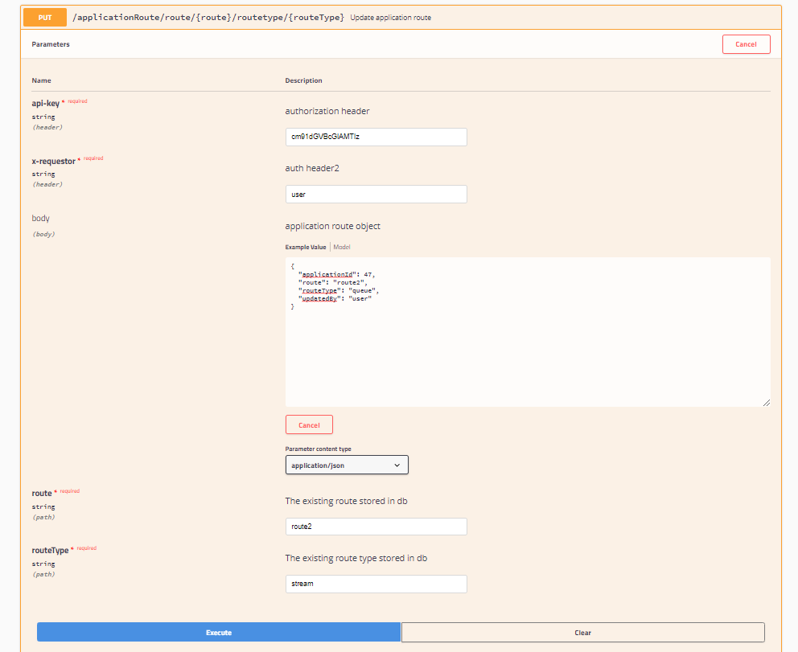



1. Create Message Type

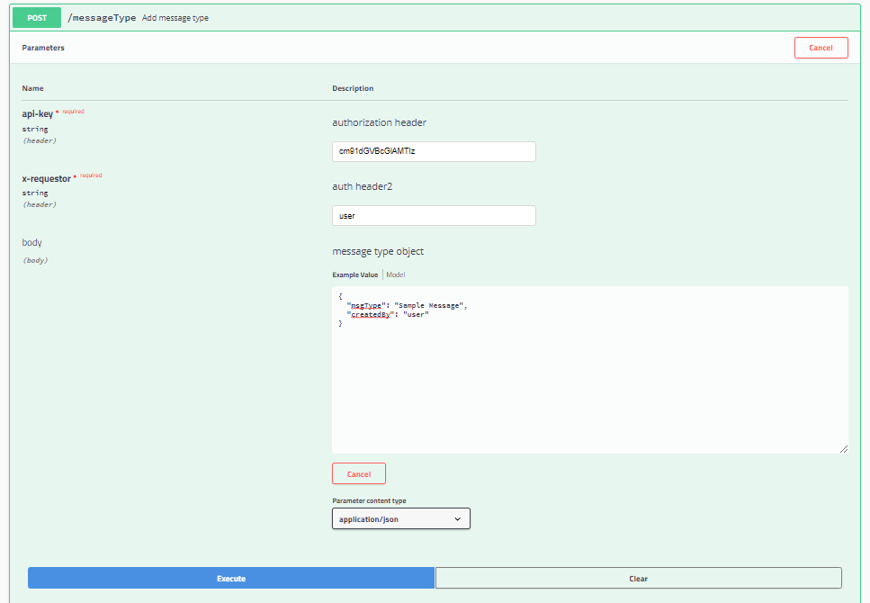

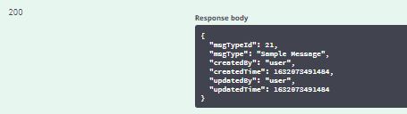

1. Get all Message Type

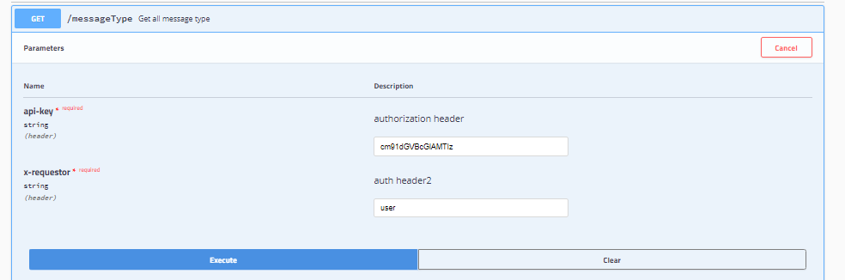

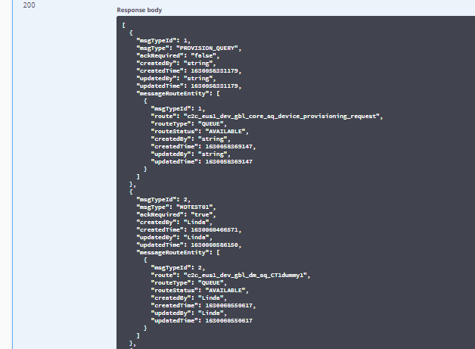

1. Get MsgType by Id

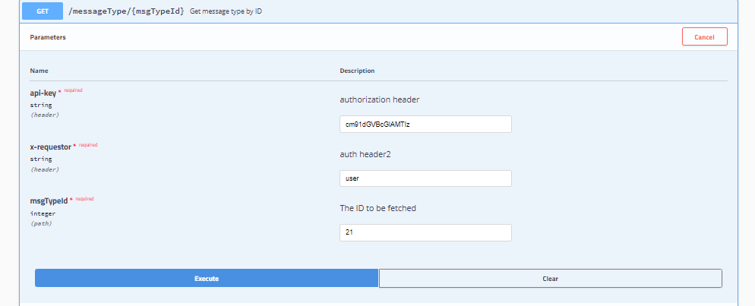

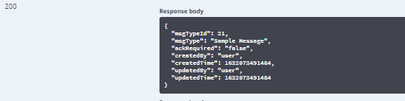

1. Add Message Route

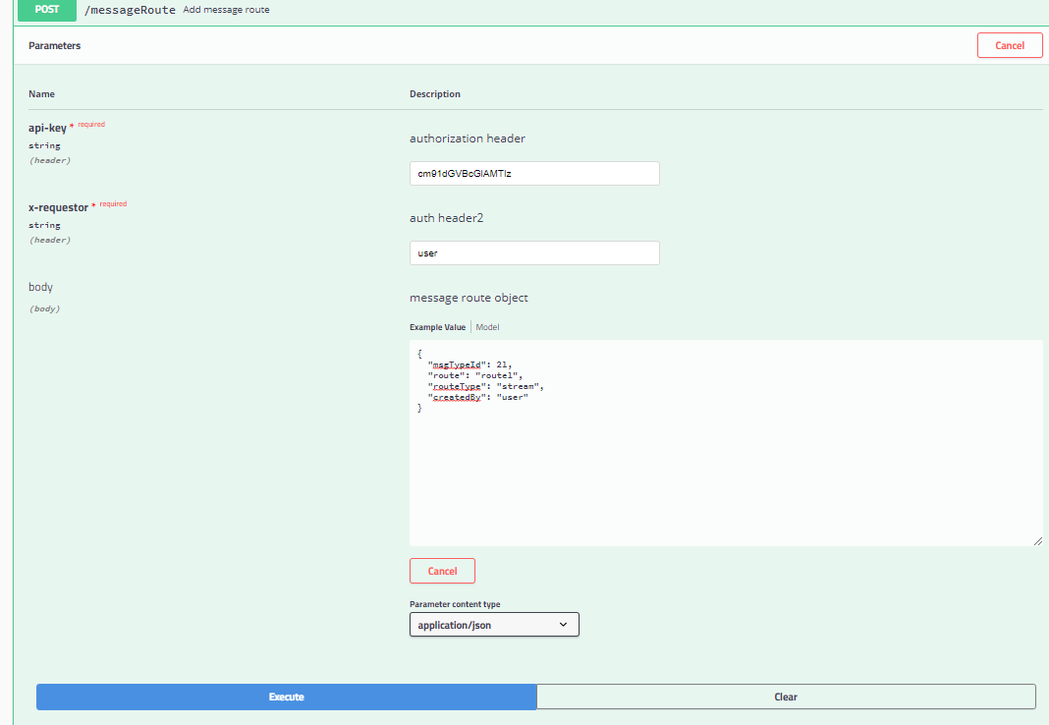

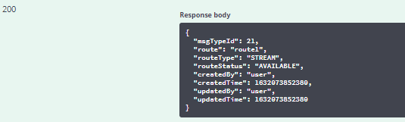

1. Get By Message Type

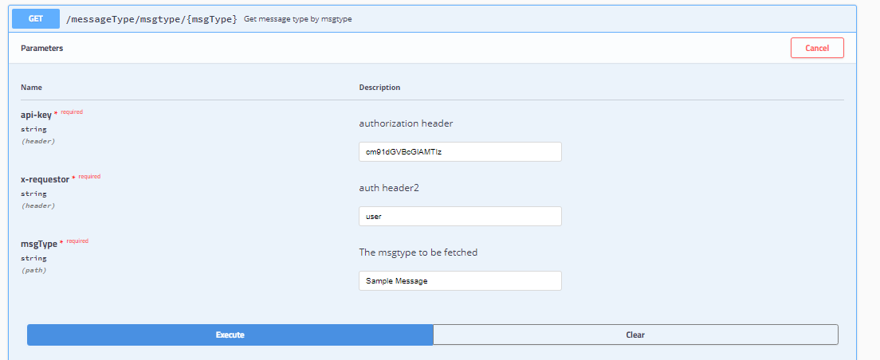

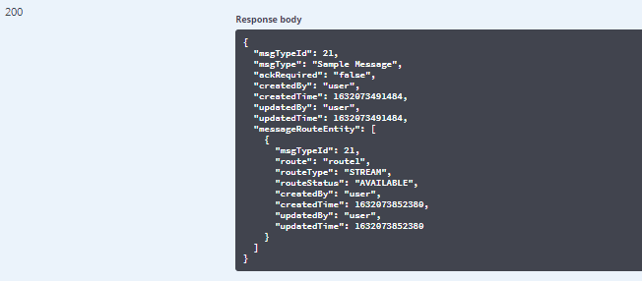

1. Update AckRequired

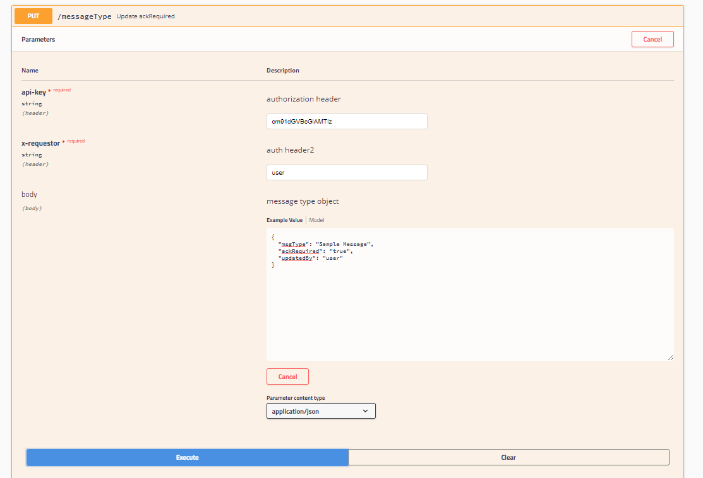



1. Get MessageRoute by Id

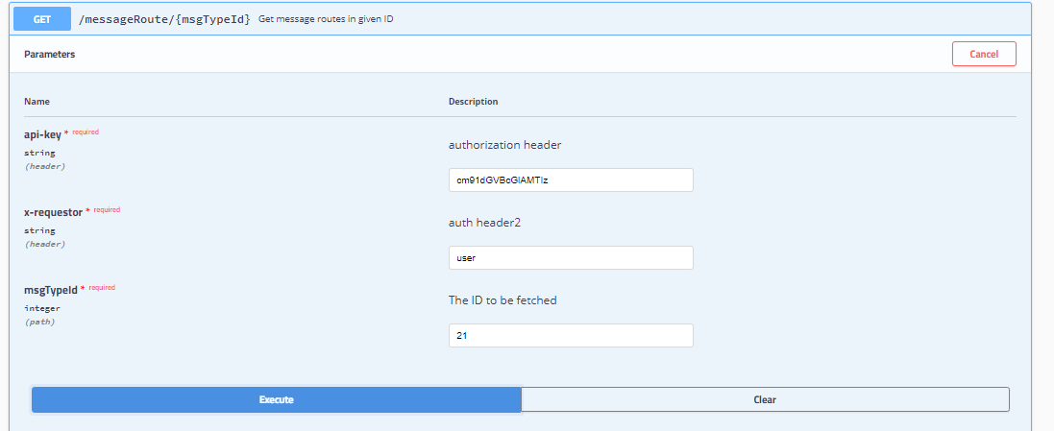

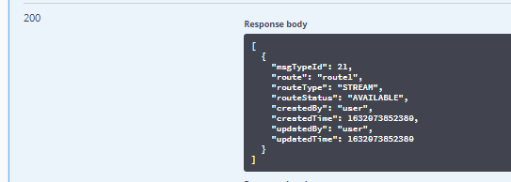

20. Get all MessageRoute

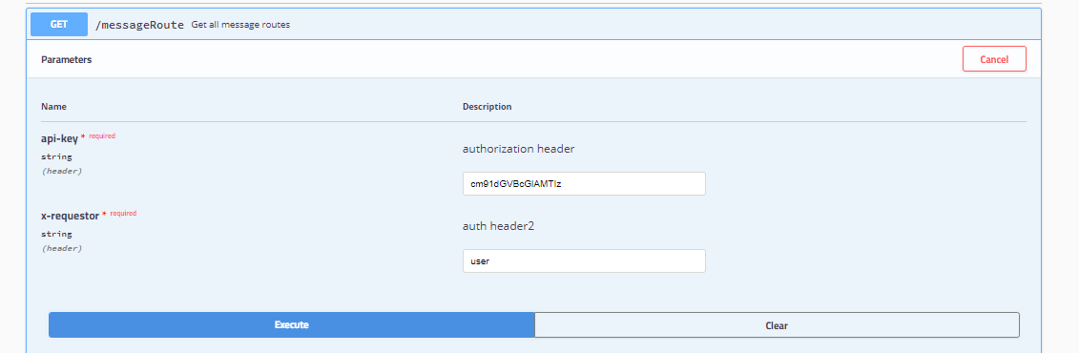

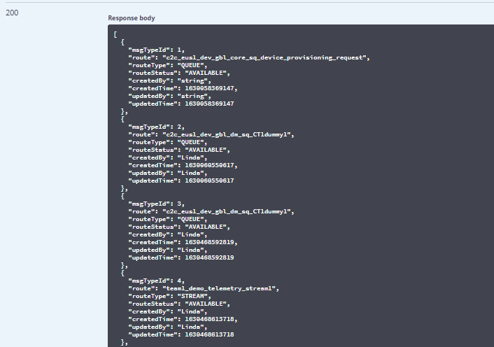

1. Update Route Status

Route Status can be set to available or not available.

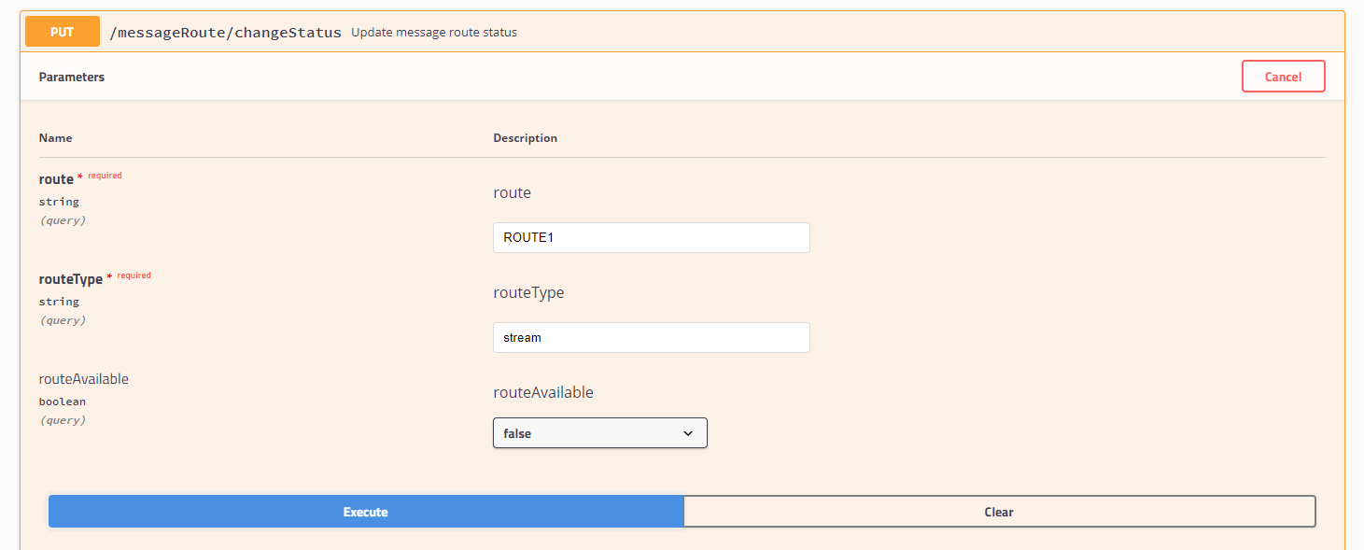



1. Update MessageRoute

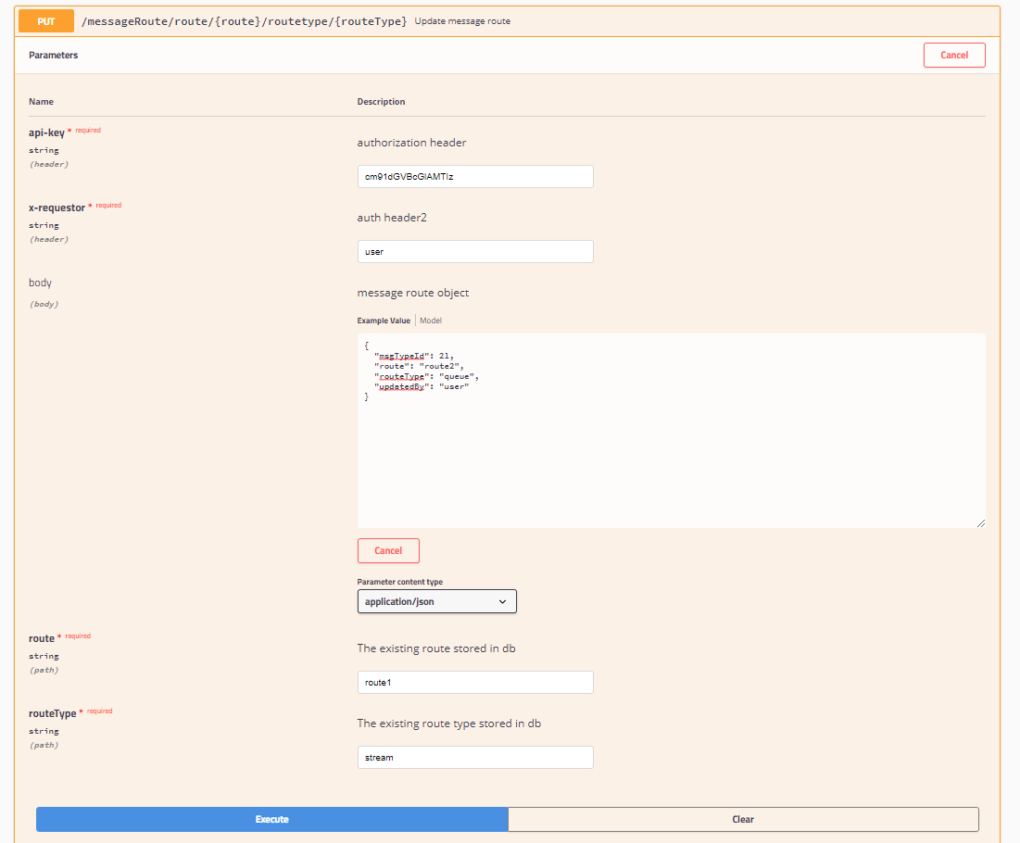

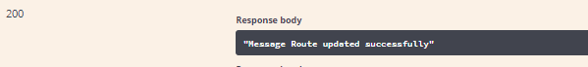

1. Delete MessageRoute

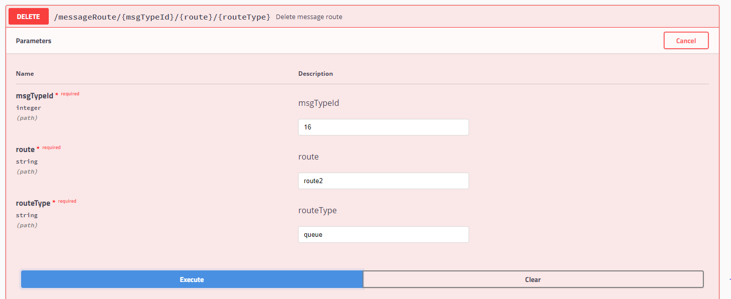



1. Delete Message Type

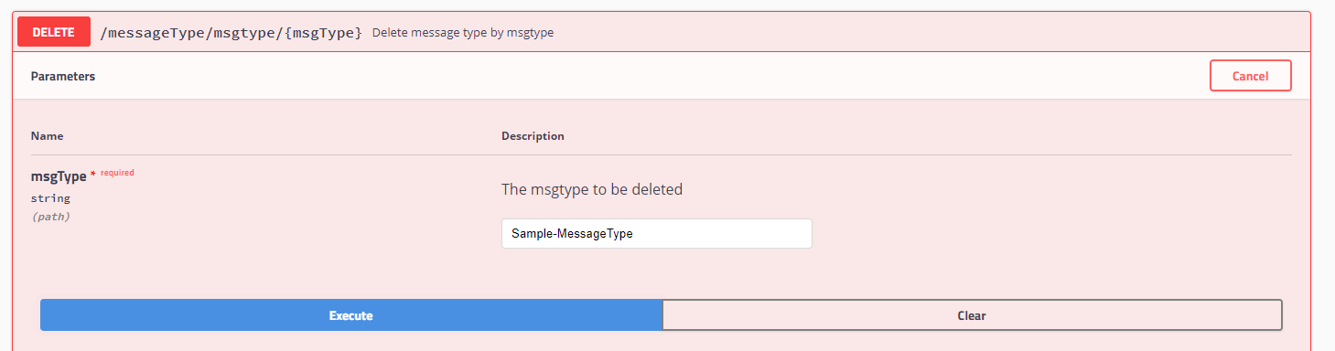



## **2.1 Http Status Codes**

• 200 success

• 400 Bad Request

• 204 No content

• 404 Not Found

For updating messageRoute and applicationRoute, gave route and routeType existing in database as path variable and route and routeType to which it should update is given in requestbody.

ApiKeys

Dev: cm91dGVBcGlAMTIz

Regional Dev: cm91dGVBcGlAMTIz